

**Name: Tetteh K. Jedidiah**

**Company: Soko Aerial**

**Email:** [**tettehjedidiah@gmail.com**](mailto:tettehjedidiah@gmail.com)

ABSTRACT: The Real-Time Messaging Protocol (RTMP) was the de facto standard for transporting video over the internet (or, in layman's terms, for streaming) in the early days of streaming. RTMP is a TCP-based protocol that is intended to maintain persistent, low-latency connections — and thus, smooth streaming experiences [1]. The aim of this article is to demonstrate how to stream videos wirelessly from DJI drones to VLC player on windows using mona server.

**INTRODUCTION**

The RTM specification is a streaming protocol that was initially designed to send audio, video, and other data between a dedicated streaming server and the Adobe Flash Player. RTMP, which was once proprietary, is now an open specification [1]. RTMP maintains a constant connection between the player client and server, allowing the protocol to act as a pipe and rapidly transfer video data to the viewer.

**MONA SERVER**

MonaServer is a ligthweight communication server supporting RTMFP, RTMP/RTMPE, WebSocket and HTTP [2]. [3] MonaServer is built on the assumption that all protocols have the same goal:

* pull data (request + response)
* push data (server - > client or client - > server)
* read/write file (VOD and recording)
* client-to-client communication channel (P2P or live publish/play).

**VLC PLAYER**

[4]VLC is a cross-platform multimedia player and framework that supports most multimedia formats as well as DVDs, Audio CDs, VCDs, and a variety of streaming protocols.

**DJI GO 4**

DJI Go 4 is an application available on iOS and Android used to provide a live video transmission feed from your drone to your smartphone. The following drones are compatible with DJI Go 4:

* Spark
* Mavic Air
* Mavic Pro
* Mavic 2 Pro / Zoom
* Phantom 4
* Phantom 4 Advanced
* Phantom 4 Pro
* Phantom 4 Pro v2.0
* Inspire 2
* Matrice 200
* Matrice 210
* Matrice 210 RTK

**INSTRUCTIONS**

* Download mona server from this link <https://sourceforge.net/projects/monaserver/files/MonaServer/MonaServer_Win64.zip/download>
* Download VLC player from this link <https://www.videolan.org/>
* Download vcredist drivers for your windowsx86 <https://aka.ms/vs/16/release/vc_redist.x86.exe>
* Download vcredist drivers for your windows <https://aka.ms/vs/16/release/vc_redist.x64.exe>
* Go to playstore and download DJI GO 4
* Extract the Mona Server zip file and save the folder anywhere on your laptop, for easy identification
* Open the Mona Server Folder and double click on the MonaServer.exe to run it

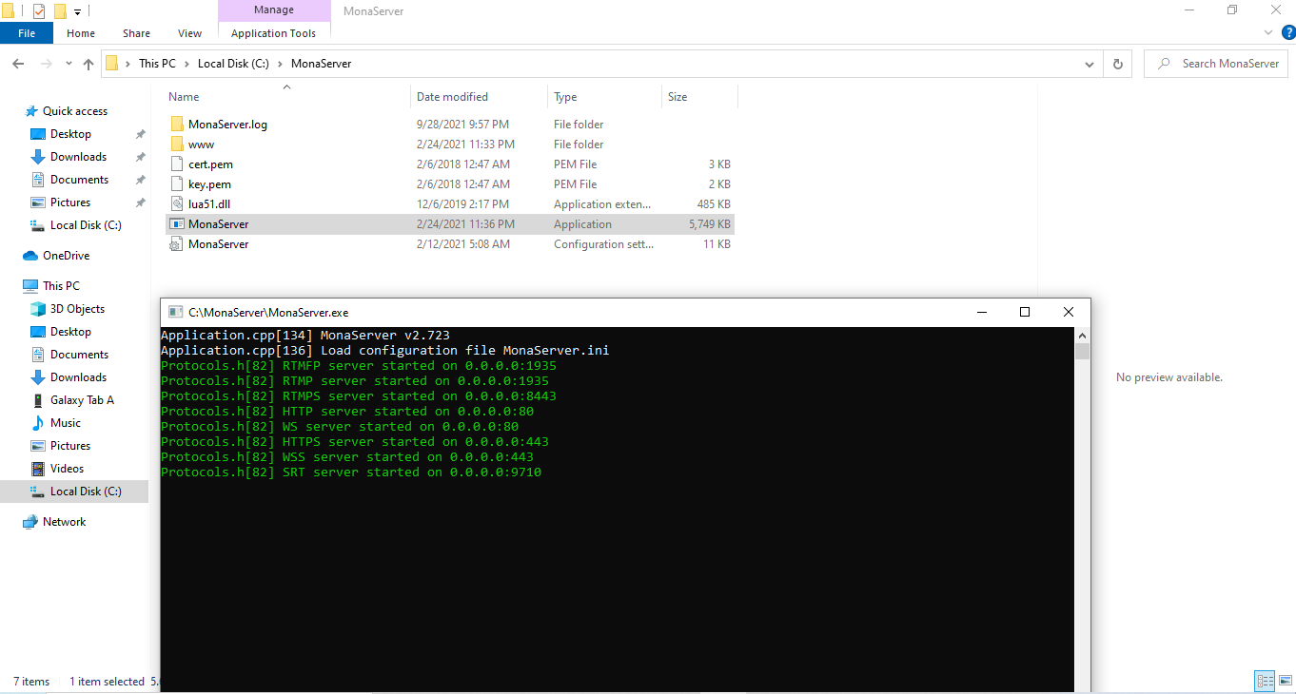

* Install DJI GO 4 and register
* Connect your phone to the DJI controller and open the DJI GO 4
* Turn on your DJI drone and connect the RC and the drone
* Your phone and laptop should share the same network
* At the left top corner of the DJI GO 4, click on the triple dots and choose Live Streaming Platform

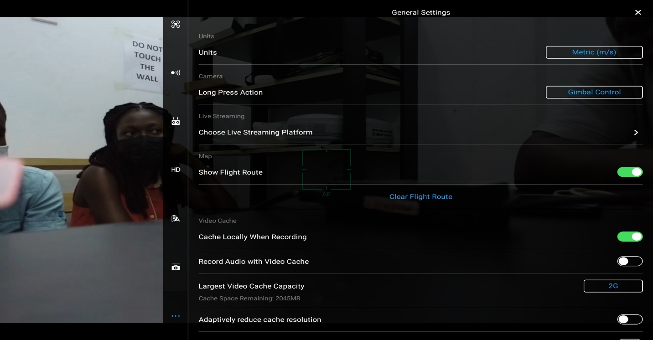

* Select Custom

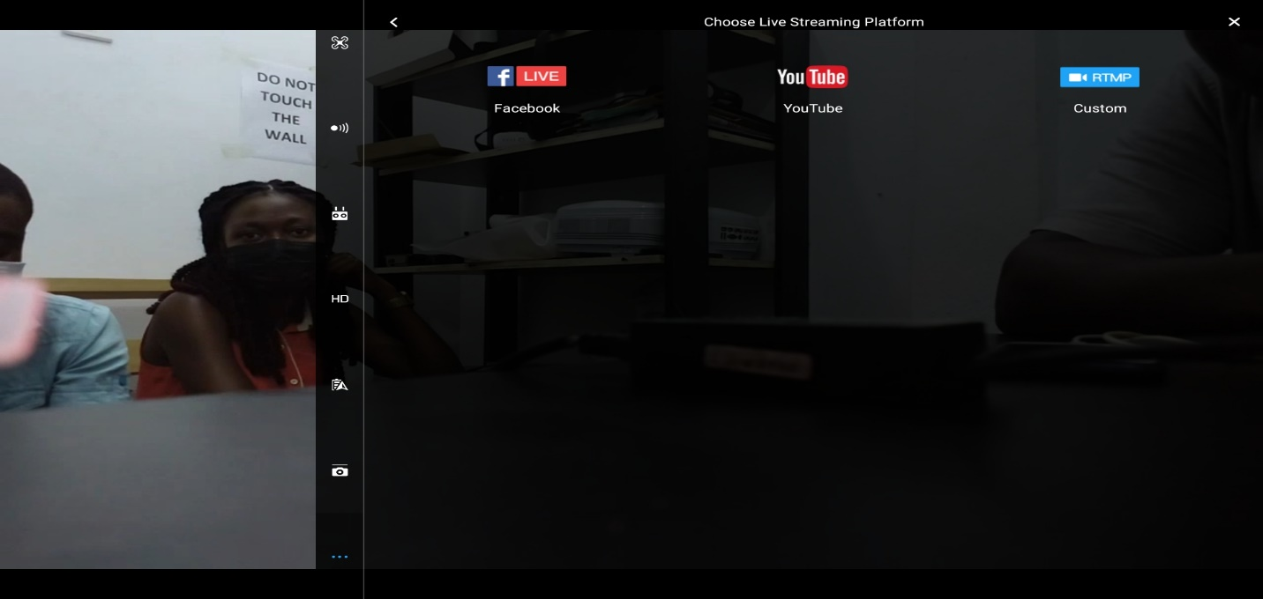

* Type the following code in the next window that appears **rtmp://laptop_IP_address:1935**

Where laptop_IP_address is the ip address of your laptop.

**CHECK FOR IP ADDRESS**

* Open command prompt and type **ipconfig**
* The ip address is the one opposite IPV4 Addres

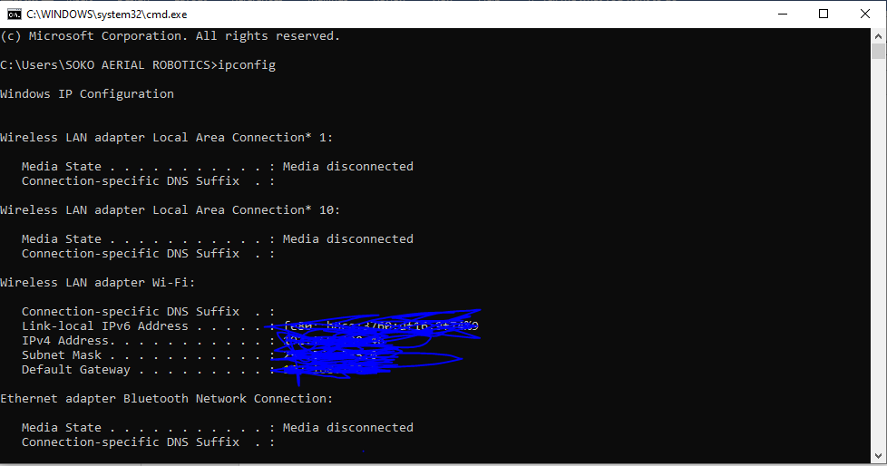

# References

|  |  |
| --- | --- |
| [1] | [Online]. Available: https://www.wowza.com/blog/rtmp-streaming-real-time-messaging-protocol. |
| [2] | [Online]. Available: https://sourceforge.net/projects/monaserver/. |
| [3] | [Online]. Available: https://www.monaserver.ovh/. |
| [4] | [Online]. Available: https://www.videolan.org/. |
| [5] | [Online]. Available: https://www.wowza.com/blog/rtmp-streaming-real-time-messaging-protocol. |